Dis-Asia-Pakistan-Harappa-Terracottas-ca. 2800-1900 BCE

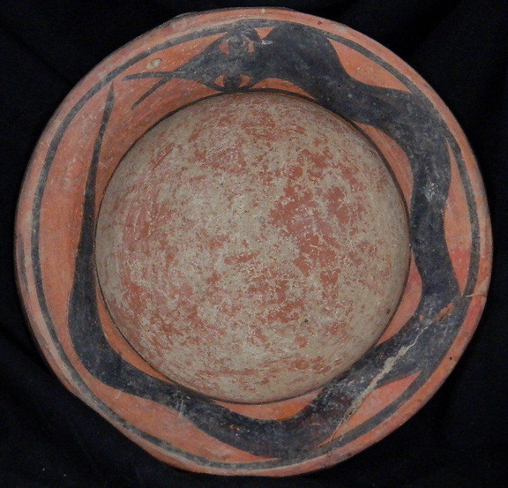 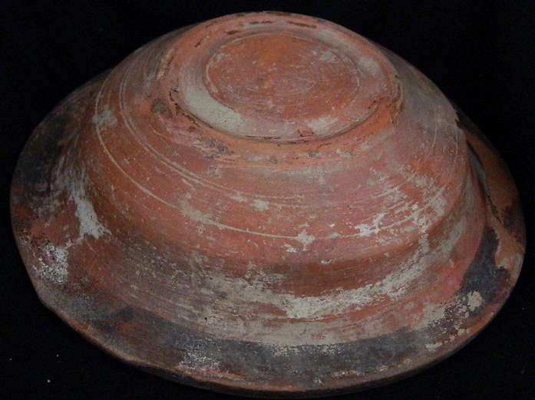

**Formal Label:** Harappa terracotta painted bowl with serpent ca. 2800-1900 BCE

**Accession Number:** **PK119.51.A1**

**Date or Time Horizon:** 2800-1900 BCE

**Geographical Area:** Harappa

**Cultural Affiliation:** Indus

**Medium:** Terracotta

**Dimensions:** H 3.0 cm, Dia-14.5 cm

**Weight:**

**Provenance:** Ex European Collection

**Condition:** Repaired/Restored rim

**Discussion:**

**References:**

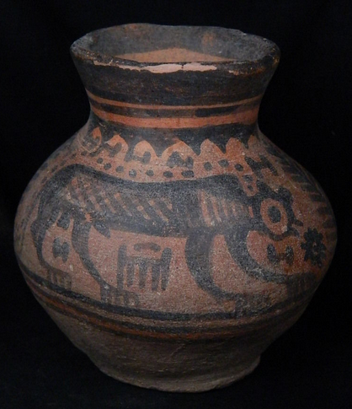 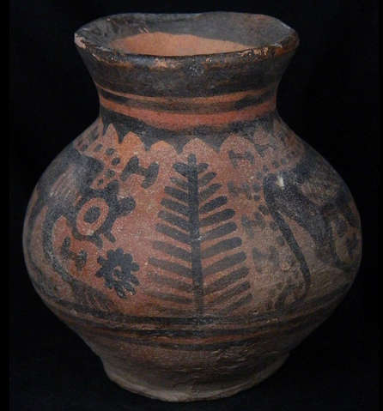 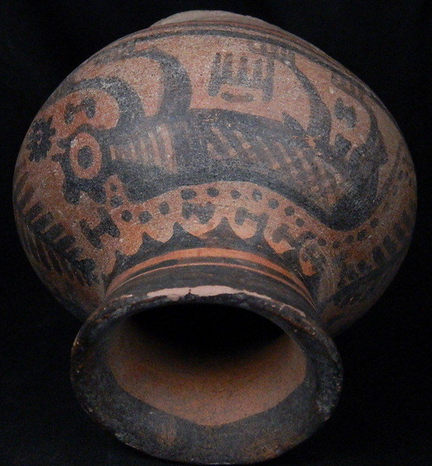 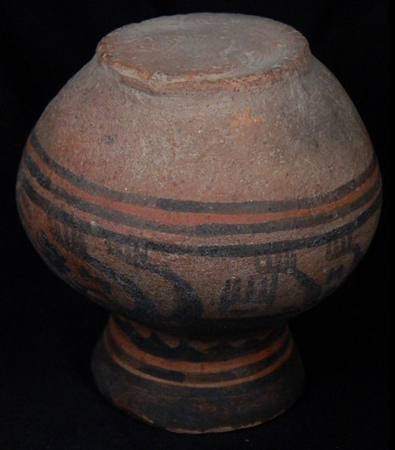

**Formal Label:** Harappa terracotta painted bowl with lion and tree of life, ca. 2800-1900 BCE

**Accession Number:** **PK119.51.A2**

**Date or Time Horizon:** 2800-1900 BCE

**Geographical Area:** Harappa

**Cultural Affiliation:** Indus

**Medium:** Terracotta

**Dimensions:** H 8.0 cm, Dia-7.5 cm

**Weight:**

**Provenance:** Ex European Collection

**Condition:** Rim chipped

References:

**Discussion:**

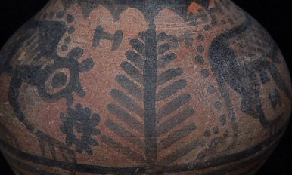

**Two lions flanking a tree of life suggests the emergence of the life of a city of the Indus civilization as a new social entity protected by the might of a lion king.**

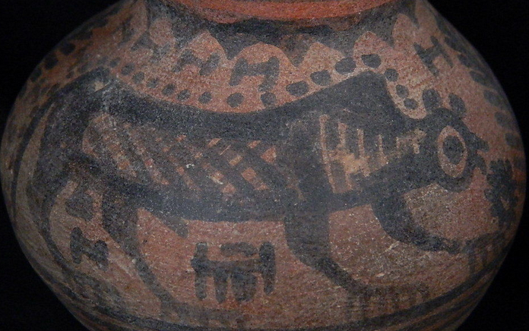

**Each lion is also surmounting a turreted city symbol |-i-i-| that symbolizes a walled city with its autonomous protection.**

**References:**

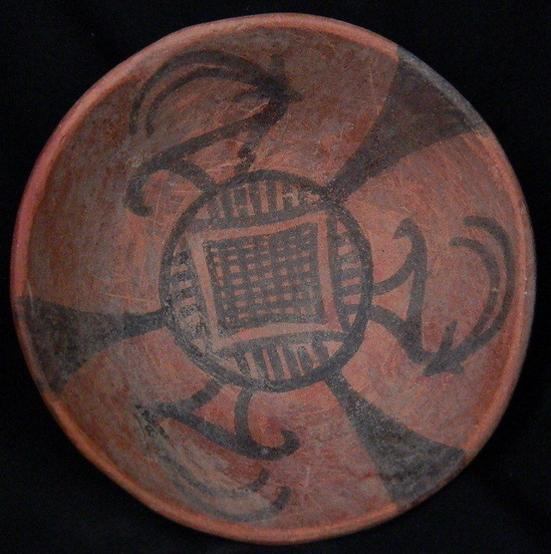 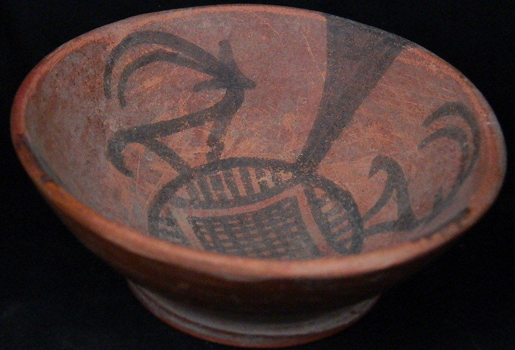 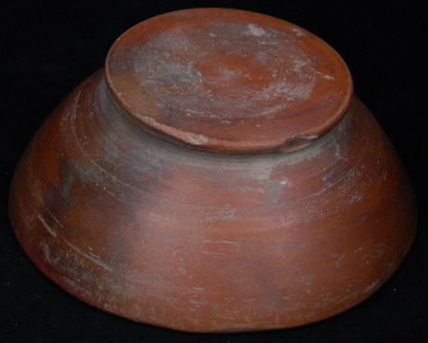**Formal Label:** Harappa terracotta painted bowl with ibex and ibex trap, ca. 2800-1900 BCE

**Accession Number:** **PK119.51.A3**

**Date or Time Horizon:** 2800-1900 BCE

**Geographical Area:** Harappa

**Cultural Affiliation:** Indus

**Medium:** Terracotta

**Dimensions:** H 3.0 cm, Dia-14.5 cm

**Weight:**

**Provenance:** Ex European Collection

**Condition:** Repaired/Restored rim

**Discussion:** The Indus valley civilization about 2500 BCE may have experienced topsoil erosion, depletion of nutrients from the soil, or a change in the course of the Indus River it may have forced them to reassess their dependency on domesticated crops. If this were the case their reliance on alternative sources of food such as hunting deer may be depicted on this bowl.

**The center of this bowl is a gridded design that suggests the terminus of a traditional animal trap at the end of a raceway: parallel lines on the cardinal edges of the gridded design suggests the sides of the raceway and the three “V” shaped designs suggest three such traps. Archaeologically, these raceway animal traps have been discovered world-wide and were an essential aspect of capturing ungulates during the Mesolithic to Neolithic transition, which is especially true of the early Indus civilizations ca 2800 BCE.**

**For instance, the Mesolithic/Neolithic horizon at Valcamonica, Italy suggests an apt comparison with the ungulate physically connected to the gridded trap design indicating “captured”.**

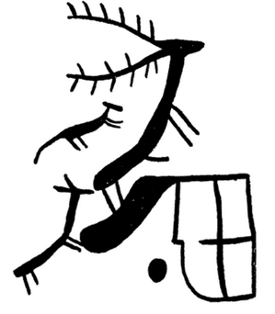

Gridded deer enclosure trap, La Grande Roche, Naquane, Valcamonica, Italy. (Bateman 1971: 35)

References:

Bateman, James A. 1971. *Animal traps and trapping*. Coch-y-Bonddu Books: Machynlleth, Wales.

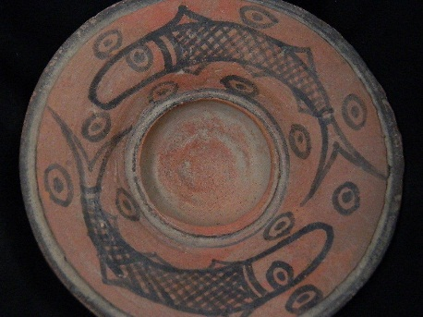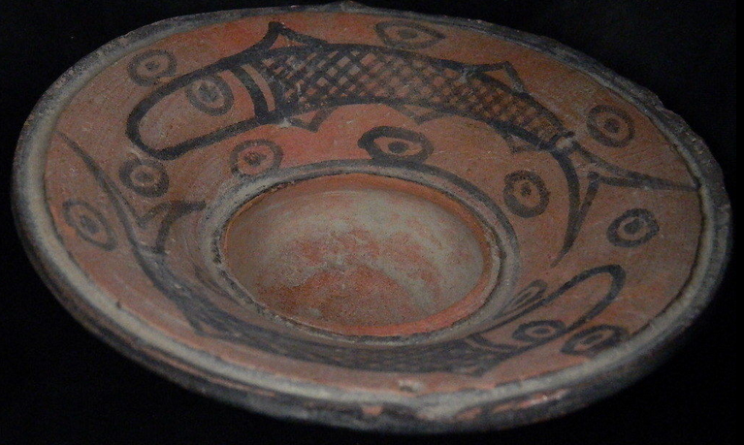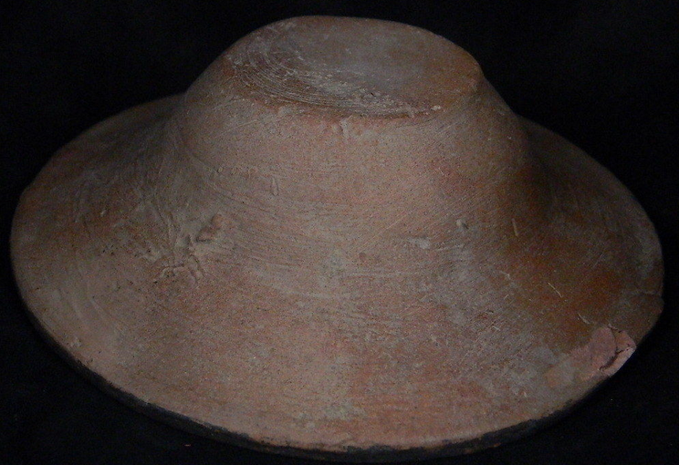**Formal Label:** Harappa terracotta painted bowl with two lanternfishes and their photopores, ca. 2800-1900 BCE

**Accession Number:** **PK119.51.A4**

**Date or Time Horizon:** 2800-1900 BCE

**Geographical Area:** Harappa

**Cultural Affiliation:** Indus

**Medium:** Terracotta

**Dimensions:** H 3.5 cm, Dia-12.5 cm

**Weight:**

**Provenance:** Ex European Collection

**Condition:** Repaired/restored rim

**Discussion:** This small mesopelagic fish of the large family Myctophidae found world-wide portrayed here is a lanternfish or myctophid (*mykter ophis*, Greek, meaning "nose" "serpent") for its large, bluntly rounded head. The most distinguishing characteristic of a lanternfish is its bioluminescence emitted from rows of small, circular to oval photophores and portrayed here as encircled dots: as this fish rises vertically from mesopelagic (200-1000 m) to epipelagic levels at dusk their emitted light can alert fishermen. This is the Diel (Latin *dies*, daily) vertical migration the greatest biomass migration on Earth when organisms ascend from the mesopelagic to the epipelagic zone (< 200m) at night and return to the mesopelagic (> 200 m) during the day. Other distinguishing lanternfish features depicted on this bowl are the large, round lateral eyes, a single high dorsal fin (3), a forked caudal fin (6), an adipose fin (4), and an anal fin (5). 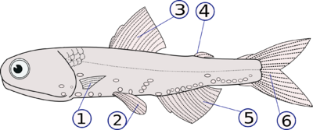

Lantern fish features from http://www.fishbase.org/images/thumbnails/gif/tn_MYCTOPT0.gif

**References:**

**Moser, H. Geoffrey and William Watson. 2004.** Bethune-Cookman College. "[Order Myctophiformes: Blackchins and Lanternfishes](https://web.archive.org/web/20011201063212/http:/www4.cookman.edu/noaa/Ichthyoplankton/Myctophiformes1.pdf)" Family Myctophidae - Lanternfishes